**TITLE OF LAB: (CLAMPERS)**

**Lab No. #06**



**Spring 2022**

**CSE-206L Electronic Circuits Lab**

Submitted by

**Safi Ullah Khan : 20PWCSE1943**

Class Section: **B**

“On my honor, as student of University of Engineering and Technology, I have neither given nor received unauthorized assistance on this academic work.”

Student Signature: ______________

Submitted to:

**Engr. Abdullah Hamid**

(Monday, June 19th, 2022)

**Department of Computer Systems Engineering**

**University of Engineering and Technology, Peshawar**

## Objectives:

* To know different types of clampers.
* To understand how clampers shifts up or down the output voltage.

## Clampers:

Clampers are circuit with the parallel combination of resistor and diode in series with capacitor. Depending on the bias of diode, the clamper may shift the output voltage up or down.

Bellow I have demonstrated a clamper that, when applied to an AC source with Vm, gives it an offset of –Vm.

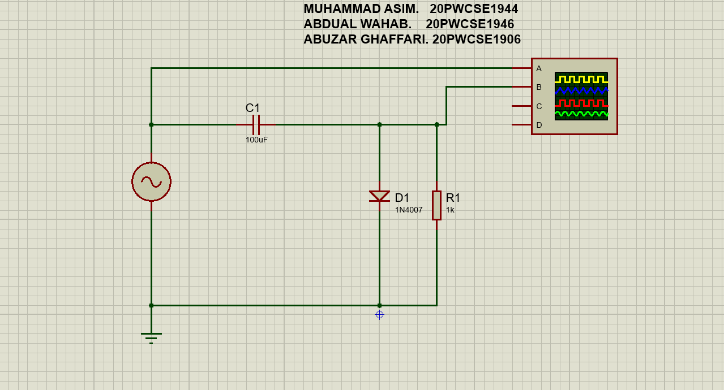

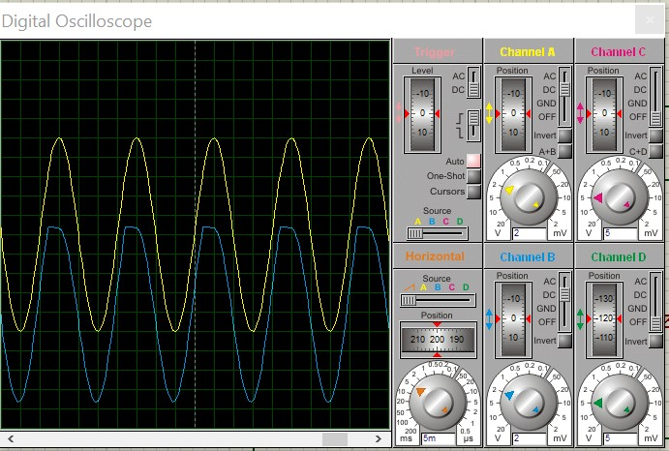

On the right side, I have provided a snip of oscilloscope output.

Since oscilloscope screen is of quite low dimensions and I could not find any way to enlarge it, I thought it would be better to include a print snip of the same oscilloscope. I later converted that print PDF to a PNG image that is given on next page.

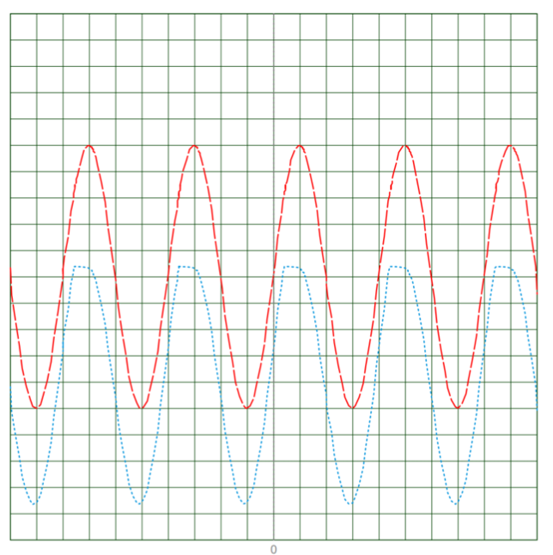

|  |  |  |  |  |  |
| --- | --- | --- | --- | --- | --- |
| V/Div | Channel A  2.00 V | Channel B  2.00 V |  | Channel C  5.00 \/ | Channel D  5.00 V |
| Offset Invert Coupling | 0.00 V Normal DC | 0.00 V Normal DC |  | 0.00 \/ Normal Off | -60.00 V  Normal Off |
|  | Horizontal |  |  | Trigger |  |
| Source | Trace |  | Source | Channel A |  |
| Position | 50.00 mS |  | Level | 0.00 V |  |
| S/Div | 5.00 mS |  | Coupling | DC |  |
|  |  |  | Edge | Rising |  |
|  |  |  | Mode | Auto |  |

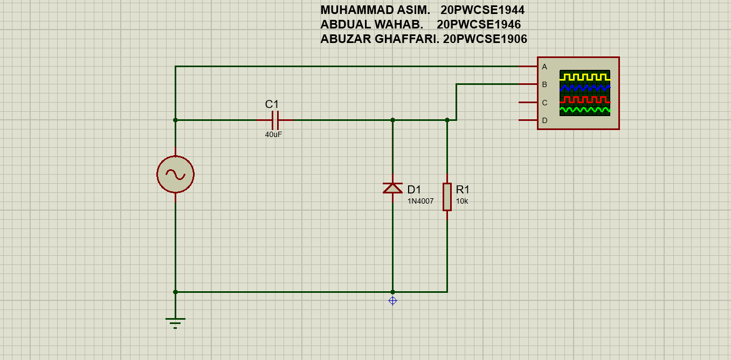

then moved on to building a clamper that shifts up by Vm.

The oscilloscope output is given bellow.

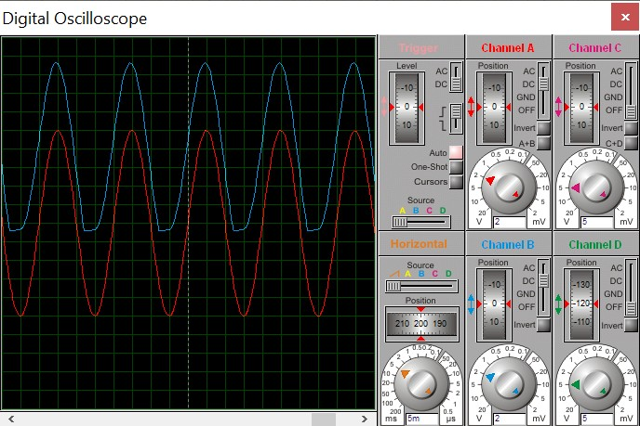

Again, I took a print and the image is pasted on next page.

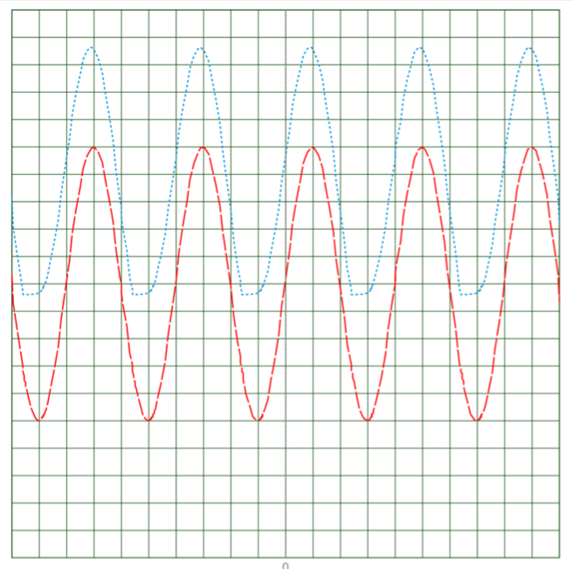

|  |  |  |  |  |
| --- | --- | --- | --- | --- |
| V/Div | Channel A  2.00 V | Channel B  2.00 V | Channel C  5.00 V | Channel D  5.00 V |
| Offset | 0.00 V | 0.00 V | 0.00 V | -60.00 V |
| Invert Coupling | Normal DC | Normal  DC | Normal Off | Normal  Off |
|  | Horizontal |  | Trigger |  |
| Source | Trace |  | Source Channel A |  |
| Position | 50.00 mS |  | Level 0.00 V |  |
| S/Div | 5.00 mS |  | Coupling DC |  |
|  |  |  | Edge Rising |  |
|  |  |  | Mode Auto |  |

Since now, I have only showed clampers that shift up or down by Vm, the amplitude of the input signal. We can also have a Vm + vcustom offset where the term vcustom is controlled by a DC source connected in series with the diode.

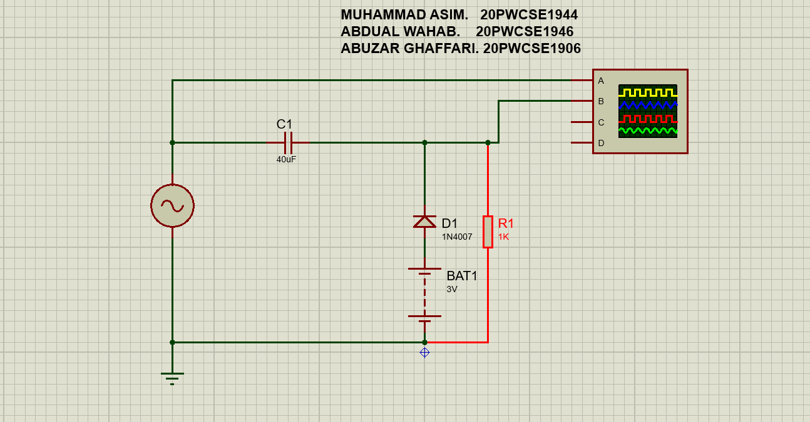

The oscilloscope output is given bellow.

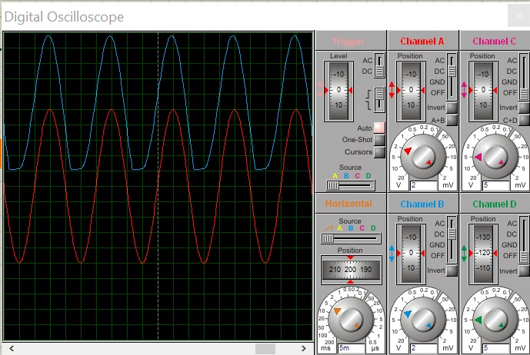

The circuit is same as previous except for a 3 V battery in series with diode which shifts by Vm

+ 3 V as opposed to Vm in previous case. Currently, the voltage of battery is getting added to the amplitude to produce final clamping amount. If we reverse polarity of battery, the same voltage will get subtracted from amplitude of signal.

**-------------------------------THE END-----------------------------**